**PROJCT NO : 6**

**AIM:** **Write an appropriate language description for a layman language which can do mathematical operations using English like sentences.**

**EXAMPLE:**

Add 100 ,200,300,400 . Sub 250 from result.

Mul 400 to it . Div the answer by 2. Show me

the answer.

# Lab3: Scanner phase implementation of assigned project in "C" language.

**Group Members:**

1. Kathiriya Darshak (IT057)
2. Limbani Nihal (IT064)
3. Karia Stuti (IT055)

We use “c++” instead of “c”.

|  |  |
| --- | --- |
| Regular Defination | Examples: |
| Keywords | From, from, Show, show, by, to, it, number, and, result, the, me, Answer, answer |
| Operation | Add, Sub, Mul, Div |
| Digit(Number) | [0-9] |
| Que. Mark | “?”//end of line |
| White Space | (Tab | Newline)**+** |
| Letter | [A-Za-z] |

**Code:**

**#include <bits/stdc++.h>**

**using namespace std;**

**int operation(char buf[])**

**{**

**char op[10][10]={"Add","add","Sub","sub","Mul","mul","Div","div"};**

**for(int i=0;i<8;i++)**

**{**

**if(strcmp(op[i],buf)==0)**

**return 1;**

**}**

**return 0;**

**}**

**int keyword(char buf[])**

**{**

**char key[20][20]={"From", "from", "Show", "show", "by", "to", "it", "number", "and", "result","Result", "the", "me", "Answer", "answer" };**

**for(int i=0;i<15;i++)**

**{**

**if(strcmp(key[i],buf)==0)**

**return 1;**

**}**

**return 0;**

**}**

**int number(char buf[])**

**{**

**int n=strlen(buf);**

**for(int i=0;i<n;i++)**

**{**

**if(buf[i]>='0' && buf[i]<='9')**

**{**

**return 1;**

**}**

**else**

**{**

**return 0;**

**}**

**}**

**return 1;**

**}**

**int main()**

**{**

**FILE *f;**

**f=freopen("D:/00 Study/SEM 6/0LAB/LT/LAB 3/inputExpfile2.txt", "r", stdin);**

**freopen("D:/00 Study/SEM 6/0LAB/LT/LAB 3/output2.txt", "w", stdout);**

**char ch,buffer[15];**

**int d=0;**

**while((ch = fgetc(f)) != EOF){**

**if(ch=='\n')**

**{**

**printf("Started New Line. \n");**

**continue;**

**}**

**if(ch=='?')**

**{**

**printf("It shown end of line: %c\n",ch);**

**continue;**

**}**

**if(isalnum(ch))**

**{**

**buffer[d++]=ch;**

**}**

**else if((ch==' ' || ch=='\n') && (d!=0)){**

**buffer[d]='\0';**

**d=0;**

**if(ch!=',')**

**{**

**if(number(buffer)==1){**

**printf("Number identify: %s\n", buffer);**

**}**

**}**

**else{**

**printf("\n");**

**continue;**

**}**

**if(operation(buffer)==1)**

**{**

**printf("operator identify: %s\n",buffer);**

**}**

**else if(keyword(buffer)==1)**

**{**

**printf("Keyword identify: %s\n",buffer);**

**}**

**}**

**else if(ch==','||ch==' ')**

**{**

**continue;**

**}**

**else**

**{**

**printf("Not identify token %c\n",ch);**

**}**

**}**

**}**

**Input File:**

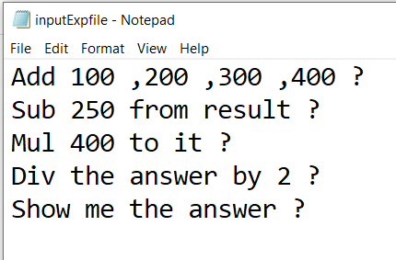

**Output File:**

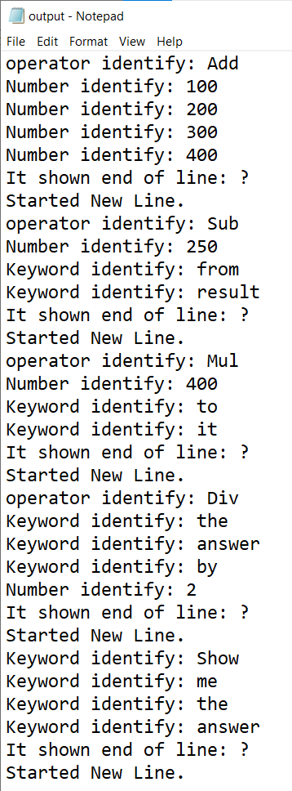

**Input File2: Show case sensitive**

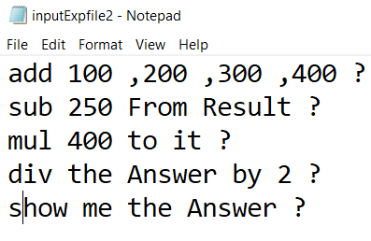

**Output File2:**

